**Lab Assignment – 5**

***Cloud Databases - GCP-SQL***

***19CSE445 – Cloud Computing***

* **Codes:**

**Signup:**

<html>

    <head>

        <link rel="stylesheet" href="index.css">

    </head>

    <body>

        <div class="mainBody">

            <form action="https://us-central1-cloud-computing-341208.cloudfunctions.net/assignment453" method="post">

            <div class="title">Sign Up</div>

            <input type="text"  name="firstname"  placeholder="First Name">

            <input type="text"  name="lastname"  placeholder="Last Name">

            <input type="text" name="username"  placeholder="User Name">

            <input type="text"  name="password"  placeholder="Password">

            <input type="text"  name="confirm"  placeholder="Confirm">

            <input class="btn" type="submit" value="submit">

        </form>

        </div>

    </body>

</html>

**Login:**

<html>

    <head>

        <link rel="stylesheet" href="index.css">

    </head>

    <body>

        <div class="mainBody">

            <form action="https://us-central1-cloud-computing-341208.cloudfunctions.net/function-2" method="post">

            <div class="title">Login</div>

            <input type="text" name="username" placeholder="User Name">

            <input type="text" name="password" placeholder="Password">

            <input class="btn" type="submit" name="" value="submit">

        </form>

        </div>

    </body>

</html>

* **MySQL Workbench:**

**Database:**

CREATE DATABASE SampleDB;

USE SampleDB;

CREATE TABLE login (username varchar(25),password varchar(25));

INSERT INTO login values ("abhinav","amrita");

INSERT INTO login values ("gowtham","ramesh");

INSERT INTO login values ("Prakash","Periyasamy");

INSERT INTO login values ("Baskar","Arumugam");

select * from login;

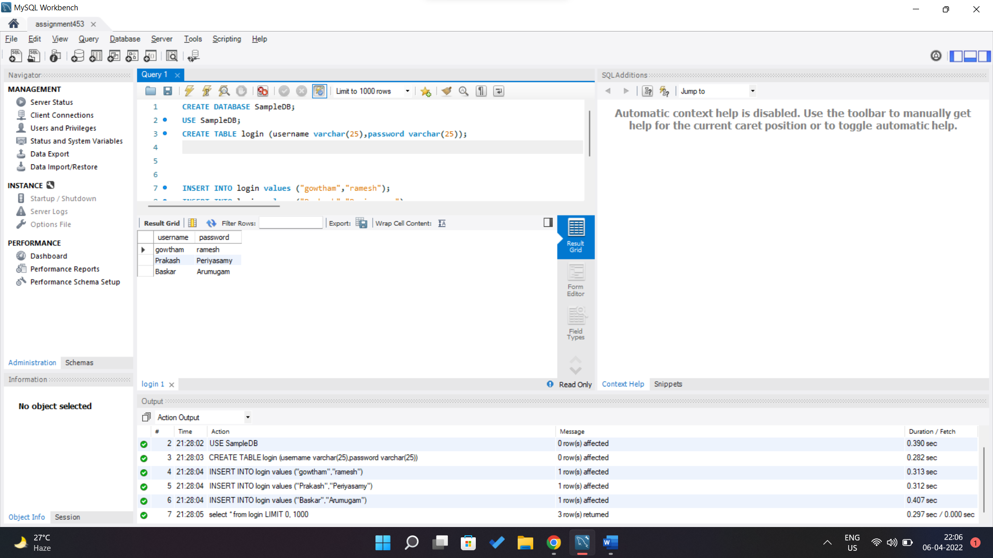

* **Function Creation:**

**Function-1:**

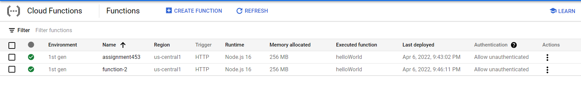

**Function-2:**

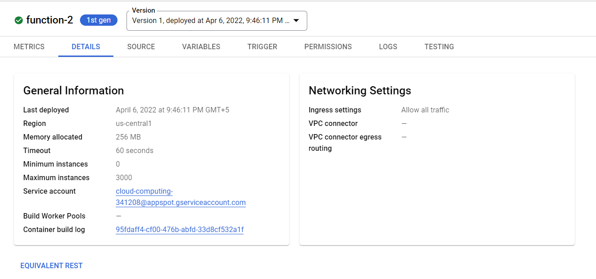

* **Bucket Creation and File Uploading:**

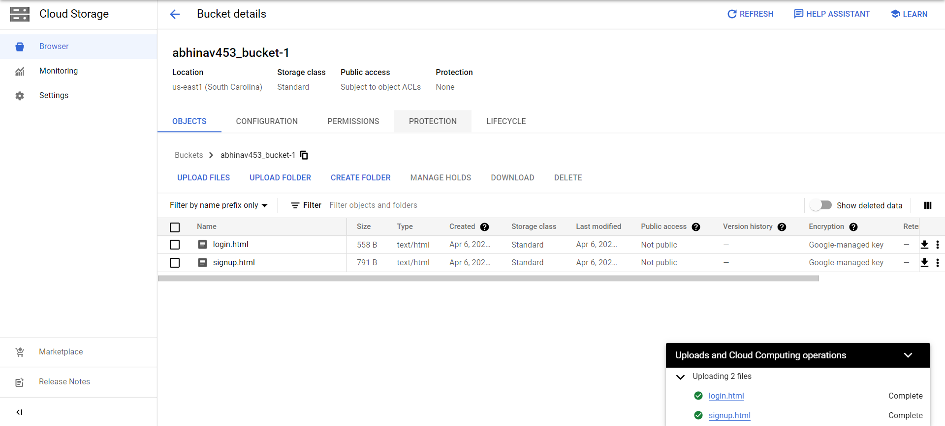

* **Running:**

